Day 2 – Issues, Workflow & Daily Usage
Learn
- Issue types: Epic, Story, Task, Bug
Studied different issue types such as Epic, Story, Task, and Bug, and understood their real-time usage in Agile projects.
- Status flow: To Do → In Progress → Done
Learned the default Jira workflow: To Do → In Progress → Done, and how teams track daily progress using this flow.
- Priority, labels, assignee, description
Understood the importance of priority, labels, assignee, and clear descriptions for effective collaboration.
Practical
- Converted 2 tasks into Bugs
Converted 2 Tasks into Bugs to simulate defect reporting.
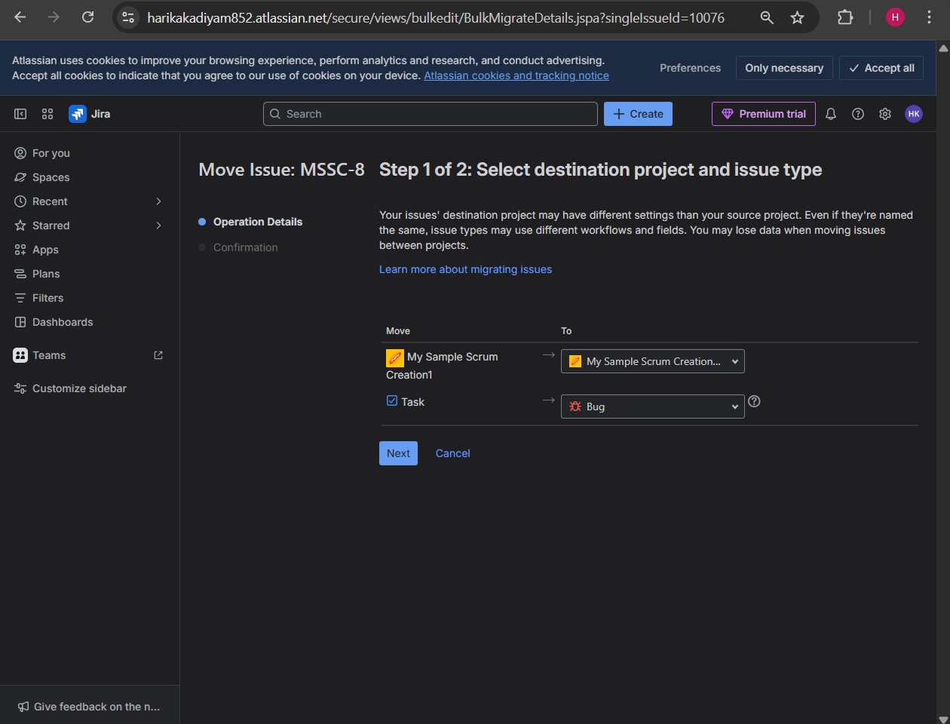
Below are the 2 tasks that are converted to bugs.
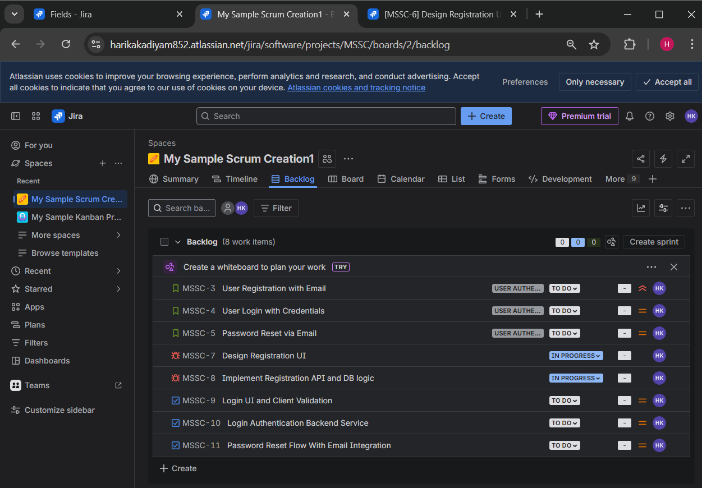
- Moved issues across workflow
Moved issues across workflow statuses based on work progress.
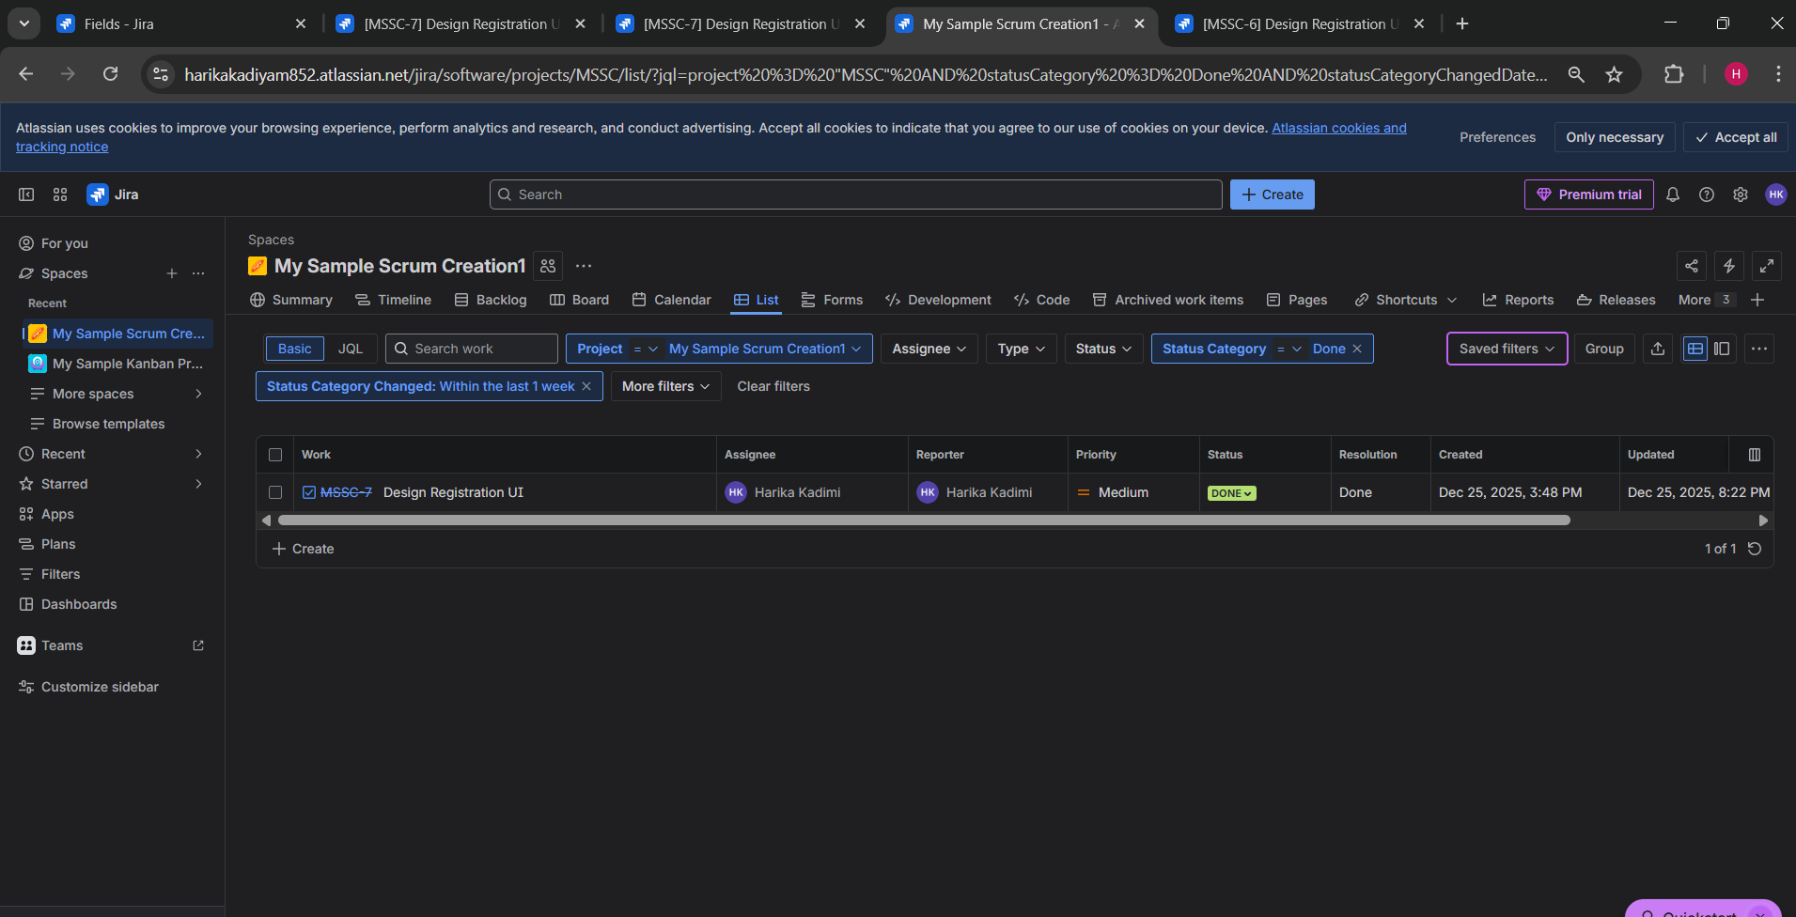
- Linked issues (blocks, relates to)
Linked issues using relationships such as blocks and relates to.
Example: Login UI and client validation is blocked by Login Authentication backend service.
Example: Password Reset via Email is relates to Password Reset Flow with Email Integration.

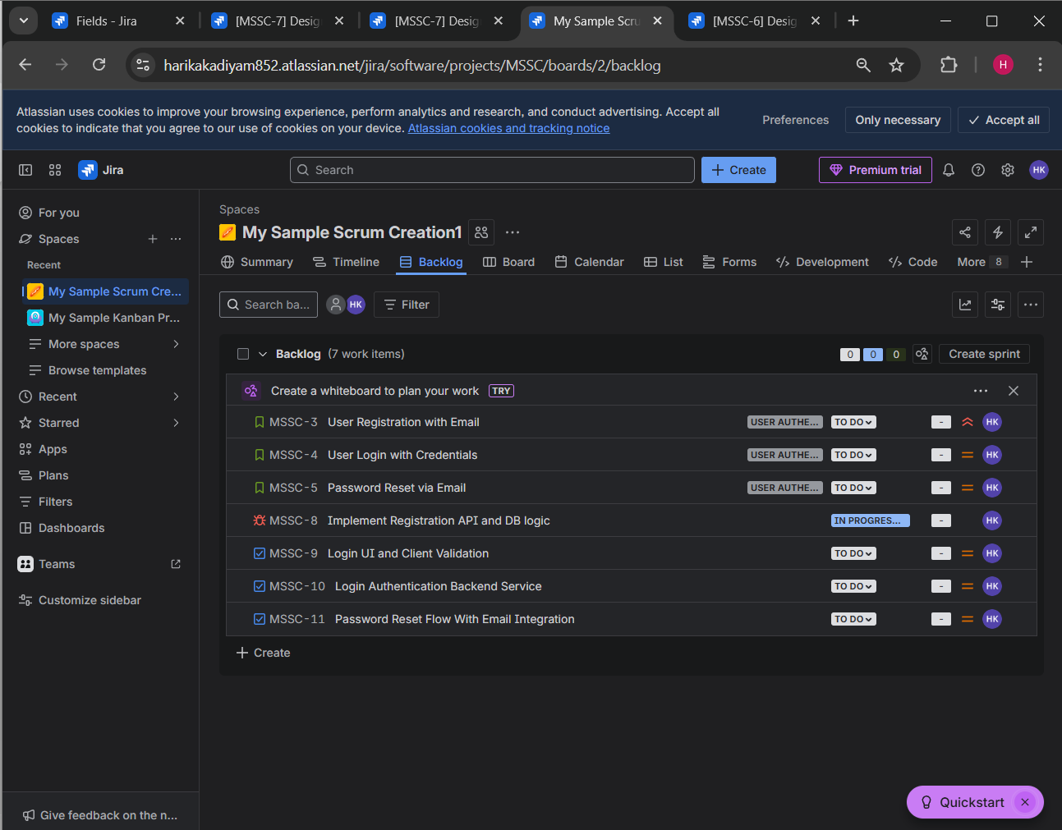
- Added comments and attachments
Added comments for communication and attachments (screenshots/logs) for better clarity as below.
